Practical lesson 15: Microbiological diagnosis of infections caused by pathogen bacteria by Corynebacterium, Bordetella, Haemophilus, Gardnerella and Legionella genus
CORYNEBACTERİUM
Important Properties
Corynebacteria are gram-positive rods that appear clubshaped (wider at one end) and are arranged in palisades or in V- or L-shaped formations . The rods have a beaded appearance. The beads consist of granules of highly polymerized polyphosphate—a storage mechanism for high-energy phosphate bonds. The granules stain metachromatically (i.e., a dye that stains the rest of the cell blue will stain the granules red).
Transmission
Humans are the only natural host of C. diphtheriae. Both toxigenic and nontoxigenic organisms reside in the upper respiratory tract and are transmitted by airborne droplets. The organism can also infect the skin at the site of a preexisting skin lesion. This occurs primarily in the tropics but can occur worldwide in indigent persons with poor skin hygiene.
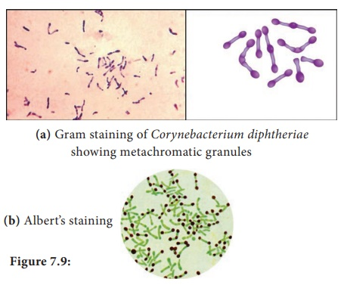
Pathogenesis
Although exotoxin production is essential for pathogenesis,invasiveness is also necessary because the organism must first establish and maintain itself in the throat. Diphtheria toxin inhibits protein synthesis by ADP-ribosylation of elongation factor-2 (EF-2). The toxin affects all eukaryotic cells regardless of tissue type but has no effect on the analogous factor in prokaryotic cells. The toxin is a single polypeptide with two functional domains. The binding (B) domain mediates binding of the toxin to glycoprotein receptors on the cell membrane. The active (A) domain possesses enzymatic activity that cleaves nicotinamide from nicotinamide adenine dinucleotide (NAD) and transfers the remaining ADP-ribose to EF-2, thereby inactivating it.The DNA that codes for diphtheria toxin is part of the DNA of a temperate bacteriophage called beta phage. During the lysogenic phase of viral growth, the DNA of this virus integrates into the bacterial chromosome and the toxin is synthesized. Corynebacterium diphtheriae cells that are not lysogenized by this phage do not produce exotoxin and are nonpathogenic. The host response to C. diphtheriae consists of the following: (1) A local inflammation in the throat, with a fibrinous exudate that forms the tough, adherent, gray pseudomembrane characteristic of the disease. (2) Antibody that can neutralize exotoxin activity by blocking the interaction of the binding domain with the receptors, thereby preventing entry into the cell. The immune status of a person can be assessed by Schick’s test. The test is performed by intradermal injection of 0.1 mL of purified standardized toxin. If the patient has no antitoxin, the toxin will cause inflammation at the site 4 to 7 days later. If no inflammation occurs, antitoxin is present and the patient is immune. The test is rarely performed in the United States except under special epidemiologic circumstances.
Clinical Findings
Although diphtheria is rare in the United States, physicians should be aware of its most prominent sign, the thick, gray,adherent pseudomembrane over the tonsils and throat. The other aspects are nonspecific: fever, sore throat, and cervical adenopathy. There are three prominent complications: (1) Extension of the membrane into the larynx and trachea, causing airway obstruction. (2) Myocarditis accompanied by arrhythmias and circulatory Collapse. (3) Nerve weakness or paralysis, especially of the cranial nerves. Paralysis of the muscles of the soft palate and pharynx can lead to regurgitation of fluids through the nose. Peripheral neuritis affecting the muscles of the extremities also occurs. Cutaneous diphtheria causes ulcerating skin lesions covered by a gray membrane. These lesions are often indolent and often do not invade surrounding tissue. Systemic symptoms rarely occur. In the United States, cutaneous diphtheria occurs primarily in the indigent.
Laboratory Diagnosis
Laboratory diagnosis involves both isolating the organism and demonstrating toxin production. It should be emphasized that the decision to treat with antitoxin is a clinical one and cannot wait for the laboratory results. A throat swab should be cultured on Loeffler’s medium, a tellurite plate, and a blood agar plate. The tellurite plate contains a tellurium salt that is reduced to elemental tellurium within the organism. The typical gray-black color of tellurium in the colony is a telltale diagnostic criterion. If C. diphtheriae is recovered from the cultures, either animal inoculation or an antibody-based gel diffusion precipitin test is performed to document toxin production. A PCR assay for the presence of the toxin gene in the organism isolated from the patient can also be used. Smears of the throat swab should be stained with both Gram stain and methylene blue. Although the diagnosis of diphtheria cannot be made by examination of the smear, the finding of many tapered, pleomorphic gram-positive rods can be suggestive. The methylene blue stain is excellent for revealing the typical metachromatic granules.

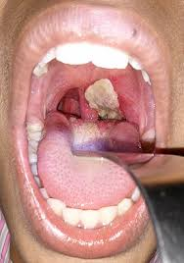
Treatment
The treatment of choice is antitoxin, which should be given immediately on the basis of clinical impression because there is a delay in laboratory diagnostic procedures. The toxin binds rapidly and irreversibly to cells and, once bound, cannot be neutralized by antitoxin. The function of antitoxin is therefore to neutralize unbound toxin in the blood. Because the antiserum is made in horses, the patient must be tested for hypersensitivity, and medications for the treatment of anaphylaxis must be available. Serum sickness may occur after administration of antiserum made in horses. Treatment with penicillin G or erythromycin is also recommended, but neither is a substitute for antitoxin. Antibiotics inhibit growth of the organism, reduce toxin production, and decrease the incidence of chronic carriers. Prevention Diphtheria is very rare in the United States because children are immunized with diphtheria toxoid (usually given as a combination of diphtheria toxoid, tetanus toxoid, and acellular pertussis vaccine, often abbreviated as DTaP). Diphtheria toxoid is prepared by treating the exotoxin with formaldehyde. This treatment inactivates the toxic effect but leaves the antigenicity intact. Immunization consists of three doses given at 2, 4, and 6 months of age, with boosters at 1 and 6 years of age. Because immunity wanes, a booster every 10 years is recommended. Immunization does not prevent nasopharyngeal carriage of the organism.

BORDETELLA
Disease
Bordetella pertussis causes whooping cough (pertussis).
Important Properties
Bordetella pertussis is a small, coccobacillary, encapsulated gram-negative rod.
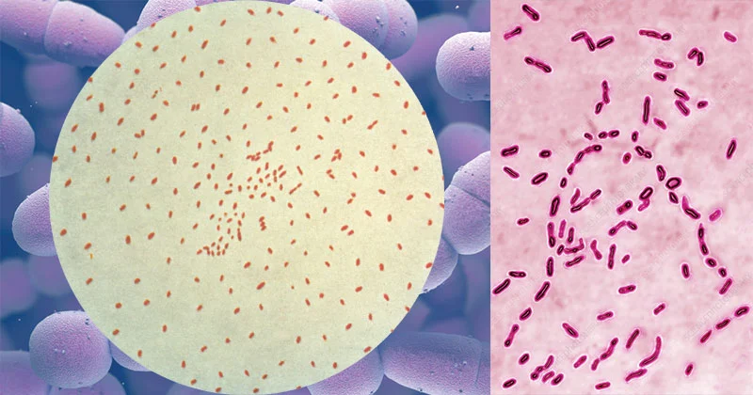
Pathogenesis & Epidemiology
Bordetella pertussis, a pathogen only for humans, is transmitted by airborne droplets produced during the severe coughing episodes. The organisms attach to the ciliated epithelium of the upper respiratory tract but do not invade the underlying tissue. Decreased cilia activity and subsequent death of the ciliated epithelial cells are important aspects of pathogenesis. Pertussis is a highly contagious disease that occurs primarily in infants and young children and has a worldwide distribution. The number of cases has declined in the United States because use of the vaccine is widespread. However, outbreaks of pertussis during the years 2005, 2010, and 2012 has led to concern about waning immunity to the vaccine and to the recommendation that an additional booster immunization be given (see “Prevention”). Several factors play a role in the pathogenesis: (1) Attachment of the organism to the cilia of the epithelial cells is mediated by a protein on the pili called filamentous hemagglutinin. Antibody against the filamentous hemagglutinin inhibits attachment and protects against disease. (2) Pertussis toxin stimulates adenylate cyclase by catalyzing the addition of adenosine diphosphate ribose—a process called ADP-ribosylation—to the inhibitory subunit of the G protein complex (Gi protein). This results in prolonged stimulation of adenylate cyclase and a consequent rise in cyclic adenosine monophosphate (AMP) and in cyclic AMP–dependent protein kinase activity. This results in edema of the respiratory mucosa that contributes to the severe cough of pertussis. The toxin also has a domain that mediates its binding to receptors on the surface of respiratory tract epithelial cells. It is an A-B subunit toxin. Pertussis toxin also causes a striking lymphocytosis in the blood of patients with pertussis. The toxin inhibits signal transduction by chemokine receptors, resulting in a failure of lymphocytes to enter lymphoid tissue such as the spleen and lymph nodes. Because the lymphocytes do not enter lymphoid tissue, there is an increase in their number in the blood. The inhibition of signal transduction by chemokine receptors is also caused by ADP-ribosylation of the Gi Protein. (3) The organisms also synthesize and export adenylate cyclase. This enzyme, when taken up by phagocytic cells (e.g., neutrophils), can inhibit their bactericidal activity. Bacterial mutants that lack cyclase activity are avirulent. (4) Tracheal cytotoxin is a fragment of the bacterial peptidoglycan that damages ciliated cells of the respiratory tract. Tracheal cytotoxin appears to act in concert with endotoxin to induce nitric oxide, which kills the ciliated epithelial cells.
Clinical Findings
Whooping cough is an acute tracheobronchitis that begins with mild upper respiratory tract symptoms followed by a severe paroxysmal cough, which lasts from 1 to 4 weeks. The paroxysmal pattern is characterized by a series of hacking coughs, accompanied by production of copious amounts of mucus, that end with an inspiratory “whoop” as air rushes past the narrowed glottis. Despite the severity of the symptoms, the organism is restricted to the respiratory tract and blood cultures are negative. A pronounced leukocytosis with up to 70% lymphocytes is seen. Although central nervous system anoxia and exhaustion can occur as a result of the severe coughing, death is due mainly to pneumonia. The classic picture of whooping cough described above occurs primarily in young children. In adults, B. pertussis infection often manifests as a paroxysmal cough of varying severity lasting weeks. The characteristic whoop is often absent, leading to difficulty in recognizing the cough as caused by this organism. In the correct clinical setting, adults with a cough lasting several weeks (often called the 100-day cough) should be evaluated for infection with B. pertussis.
Laboratory Diagnosis
The organism can be isolated from nasopharyngeal swabs taken during the paroxysmal stage. Bordet-Gengou1 medium used for this purpose contains a high percentage of blood (20%–30%) to inactivate inhibitors in the agar. Identification of the isolated organism can be made by agglutination with specific antiserum or by fluorescentantibody staining. However, the organism grows very slowly in culture, so direct fluorescent-antibody staining of the nasopharyngeal specimens can be used for diagnosis. Polymerase chain reaction–based tests are highly specific and sensitive and should be used if available. Isolation of the organism in patients with a prolonged cough is often difficult. Serologic tests that detect antibody in the patient’s serum can be used for diagnosis in those patients.
Treatment
Azithromycin is the drug of choice. Note that azithromycin reduces the number of organisms in the throat and decreases the risk of secondary complications but has little effect on the course of the disease at the “prolonged cough” stage because the toxins have already damaged the respiratory mucosa. Supportive care (e.g., oxygen therapy and suction of mucus) during the paroxysmal stage is important, especially in infants.
Prevention
There are two types of vaccines: an acellular vaccine containing purified proteins from the organism and a killed vaccine containing inactivated B. pertussis organisms. The acellular vaccine contains five antigens purified from the organism. It is the vaccine currently used in the United States. The main immunogen in this vaccine is inactivated pertussis toxin (pertussis toxoid). The toxoid in the vaccine is pertussis toxin that has been inactivated genetically by introducing two amino acid changes, which eliminates its ADP-ribosylating activity but retains its antigenicity. It is the first vaccine to contain a genetically inactivated toxoid. The other pertussis antigens in the vaccine are filamentous hemagglutinin, pertactin, and fimbriae types 2 and 3. The acellular vaccine has fewer side effects than the killed vaccine but has a shorter duration of immunity. The pertussis vaccine is usually given combined with diphtheria and tetanus toxoids (DTaP) in three doses beginning at 2 months of age. A booster at 12 to 15 months of age and another at the time of entering school are recommended. Because outbreaks of pertussis have occurred among teenagers, a booster for those between 10 and 18 years old is recommended. This vaccine, called Boostrix, contains diphtheria and tetanus toxoids also.

HAEMOPHILUS
Diseases
Hemophilus influenzae used to be the leading cause of meningitis in young children, but the use of the highly effective “conjugate” vaccine has greatly reduced the incidence of meningitis caused by this organism. It is still an important cause of upper respiratory tract infections (otitis media, sinusitis, conjunctivitis, and epiglottitis) and sepsis in children. It also causes pneumonia in adults, particularly in those with chronic obstructive lung disease.
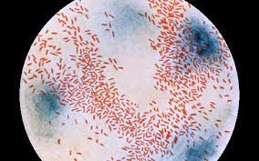
Important Properties
Hemophilus influenzae is a small gram-negative rod (coccobacillary rod)) with a polysaccharide capsule.It is one of the three important encapsulated pyogens, along with the pneumococcus and the meningococcus. Serologic typing is based on the antigenicity of the capsular polysaccharide. Of the six serotypes (a–f), type b is the most important. Type b used to cause most of the severe, invasive diseases, such as meningitis and sepsis, but the widespread use of the vaccine containing the type b capsular polysaccharide as the immunogen, has greatly reduced the incidence of invasive disease caused by this type. The type b capsule is composed of polyribitol phosphate. Unencapsulated strains can also cause disease, especially mucosal diseases of the upper respiratory tract such as sinusitis and otitis media, but are usually noninvasive. Growth of the organism on laboratory media requires the addition of two components, heme (factor X) and NAD (factor V), for adequate energy production.
Pathogenesis & Epidemiology
Hemophilus influenzae infects only humans; there is no animal reservoir. It enters the body by the inhalation of airborne droplets into the respiratory tract, resulting in either asymptomatic colonization or infections such as otitis media, sinusitis, or pneumonia. The organism produces an IgA protease that degrades secretory IgA, thus facilitating attachment to the respiratory mucosa. After becoming establishedin the upper respiratory tract, the organism can enter the bloodstream (bacteremia) and spread to the meninges. Meningitis is caused primarily by the encapsulated strains, but nonencapsulated strains are frequently involved in otitis media, sinusitis, and pneumonia. Note that the incidence of meningitis caused by capsular type b has been greatly reduced because the vaccine contains the type b polysaccharide as the immunogen. Pathogenesis of H. influenzae involves its antiphagocytic capsule and endotoxin; no exotoxin is produced. Most infections occur in children between the ages of 6 months and 6 years, with a peak in the age group from 6 months to 1 year. This age distribution is attributed to a decline in maternal IgG in the child coupled with the inability of the child to generate sufficient antibody against the polysaccharide capsular antigen until the age of approximately 2 years.
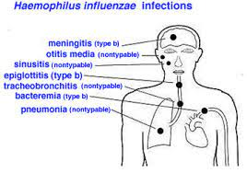
Clinical Findings
Meningitis caused by H. influenzae cannot be distinguished on clinical grounds from that caused by other bacterial pathogens (e.g., pneumococci or meningococci). The rapid onset of fever, headache, and stiff neck, along with drowsiness, is typical. Sinusitis and otitis media cause pain in the affected area, opacification of the infected sinus, and redness with bulging of the tympanic membrane. Hemophilus influenzae is second only to the pneumococcus as a cause of these two infections. Other serious infections caused by this organism include septic arthritis, cellulitis, and sepsis, the latter occurring especially in splenectomized patients. Rarely, epiglottitis, which can obstruct the airway, occurs. A swollen “cherryred” epiglottis is seen. This life-threatening disease of young children is caused almost exclusively by H. influenzae. Pneumonia in elderly adults, especially those with chronic respiratory disease, can be caused by untypeable strains of H. influenzae.
Laboratory Diagnosis
Laboratory diagnosis depends on isolation of the organism on heated-blood (“chocolate”) agar enriched with two growth factors required for bacterial respiration, namely, factor X (a heme compound) and factor V (NAD). The blood used in chocolate agar is heated to inactivate nonspecific inhibitors of H. influenzae growth. An organism that grows only in the presence of both growth factors is presumptively identified as H. influenzae; other species of Haemophilus, such as Haemophilus parainfluenzae, do not require both factors. Definitive identification can be made with either biochemical tests or the capsular swelling (quellung) reaction. Additional means of identifying encapsulated strains include fluorescent-antibody staining of the organism and counterimmunoelectrophoresis or latex agglutination tests, which detect the capsular polysaccharide.
Treatment
The treatment of choice for meningitis or other serious systemic infections caused by H. influenzae is ceftriaxone. From 20% to 30% of H. influenzae type b isolates produce a β-lactamase that degrades penicillinase-sensitive β-lactams such as ampicillin but not ceftriaxone. It is important to institute antibiotic treatment promptly, because the incidence of neurologic sequelae (e.g., subdural empyema) is high. Untreated H. influenzae meningitis has a fatality rate of approximately 90%. H. influenzae upper respiratory tract infections, such as otitis media and sinusitis, are treated with either amoxicillin-clavulanate or trimethoprim-sulfamethoxazole
Prevention
The vaccine contains the capsular polysaccharide of H. influenzae type b conjugated to diphtheria toxoid or other carrier protein. This vaccine is much more effective in young children than the unconjugated vaccine and has reduced the incidence of meningitis caused by this organism by approximately 90% in immunized children. Meningitis in close contacts of the patient can be prevented by rifampin. Rifampin is used because it is secreted in the saliva to a greater extent than ampicillin. Rifampin decreases respiratory carriage of the organism, thereby reducing transmission

GARDNERELLA
Gardnerella vaginalis is the main organism associated with bacterial vaginosis. This disease is the most common vaginal infection of sexually active women.
Important Properties
Gardnerella vaginalis is a small, facultative gram-variable rod. The term “gram-variable” refers to the observation that some organisms are purple while others are pink in a Gram-stained specimen. Structurally, it has a gram-positive cell wall but the wall is thin and older organisms tend to lose the purple color.
Pathogenesis
The pathogenesis of bacterial vaginosis is uncertain. Gardnerella vaginalis is often found in association with anaerobes such as Mobiluncus and together they cause the symptoms of this disease. It is not considered to be a sexually transmitted infection.
Clinical Findings
Bacterial vaginosis is characterized by a malodorous, white or gray-colored vaginal discharge. The discharge has a characteristic “fishy” odor. Inflammatory changes are typically absent which is why it is called a “vaginosis” rather than a “vaginitis.” Mild itching may occur. Women with bacterial vaginosis have a higher incidence of preterm deliveries and, consequently, a higher incidence of morbidity and mortality occurs in their newborn children.
Laboratory Diagnosis
Clue cells, which are vaginal epithelial cells covered with bacteria, are an important laboratory finding seen in a microscopic examination of the vaginal discharge (Figure 17-9). In addition, the “whiff” test, which consists of treating the vaginal discharge with 10% KOH and smelling a pungent, “fishy” odor, is often positive. However, trichomoniasis, which can also cause a positive whiff test, must be ruled out before a diagnosis of bacterial vaginosis can be made. A pH of greater than 4.5 of the vaginal discharge supports the diagnosis of bacterial vaginosis.
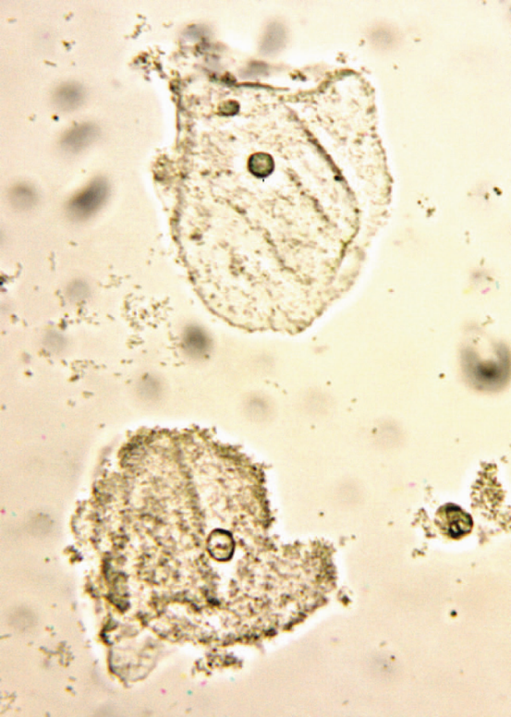
Clue cells in bacterial vaginosis. Note that the lower epithelial cell is a "clue cell" because its surface is covered with bacteria. The upper epithelial cell is not a "clue cell" because its surface has few bacteria.

Treatment and Prevention
The drug of choice is metronidazole. Treatment of sexual partners is not recommended. There is no vaccine.
LEGIONELLA
Disease
Legionella pneumophila (and other legionellae) causes pneumonia, both in the community and in hospitalized immunocompromised patients. The genus is named after the famous outbreak of pneumonia among people attending the American Legion convention in Philadelphia in 1976 (Legionnaires’ disease).
Important Properties
Legionellae are gram-negative rods that stain faintly with the standard Gram stain. They do, however, have a gram-negative type of cell wall, and increasing the time of the safranin counterstain enhances visibility. Legionellae in lung biopsy sections do not stain by the standard hematoxylin-and-eosin (H&E) procedure; therefore, special methods, such as the Dieterle silver impregnation stain, are used to visualize the organisms. During the 1976 outbreak, initial attempts to grow the organisms on ordinary culture media failed. This is because the organism requires a high concentration of iron and cysteine. Culture media supplemented with these nutrients will support growth. Legionella pneumophila causes approximately 90% of pneumonia attributed to legionellae. There are 16 serogroups of L. pneumophila, with most cases caused by serogroup 1 organisms. There are about 30 other Legionella species that cause pneumonia, but most of the remaining 10% of cases are caused by two species, Legionella micdadei and Legionella bozemanii.
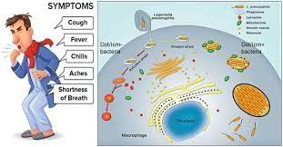
Pathogenesis & Epidemiology
Legionellae are associated chiefly with environmental water sources such as air conditioners and water-cooling towers. Outbreaks of pneumonia in hospitals have been attributed to the presence of the organism in water taps, sinks, and showers. Legionellae can replicate to large numbers in free-living amebas in these water sources. The amebas also enhance the survival of Legionellae. Under adverse environmental conditions, the amebas encyst, ensuring both their own survival and the survival of the intracellular Legionellae as well. The portal of entry is the respiratory tract, and pathologic changes occur primarily in the lung. However, in severe cases, bacteremia occurs, accompanied by damage to the vascular endothelium in multiple organs, especially the brain and kidneys. The major virulence factor of the organism is lipopolysaccharide (endotoxin). No exotoxins are produced. The typical candidate for Legionnaires’ disease is an older man who smokes and consumes substantial amounts of alcohol. Patients with acquired immunodeficiency syndrome (AIDS), cancer, or transplants (especially renal transplants) or patients being treated with corticosteroids are predisposed to Legionella pneumonia, which indicates that cell-mediated immunity is the most important defense mechanism. Despite airborne transmission of the organism, person-toperson spread does not occur, as shown by the failure of secondary cases to occur in close contacts of patients.
Clinical Findings
The clinical picture can vary from a mild influenzalike illness to a severe pneumonia accompanied by mental confusion, nonbloody diarrhea, proteinuria, and microscopic hematuria. Although cough is a prominent symptom, sputum is frequently scanty and nonpurulent. Hyponatremia is an important laboratory finding that occurs more often in Legionella pneumonia than in pneumonia caused by other bacteria. Most cases resolve spontaneously in 7 to 10 days, but in older or immunocompromised patients, the infection can be fatal. Legionellosis is an atypical pneumonia2 and must be distinguished from other similar pneumonias such as Mycoplasma pneumonia, viral pneumonia, psittacosis, and Q fever. Pontiac fever is a mild, flulike form of Legionella infection that does not result in pneumonia.
Laboratory Diagnosis
Sputum Gram stains reveal many neutrophils but no bacteria. The organism fails to grow on ordinary media in a culture of sputum or blood, but it will grow on charcoalyeast agar, a special medium supplemented with iron and cysteine. Diagnosis usually depends on a significant increase in antibody titer in convalescent-phase serum by the indirect immunofluorescence assay. Detection of L. pneumophila antigens in the urine is a rapid means of making a diagnosis. The urinary antigen test is available only for serogroup 1 organisms. If tissue is available, it is possible to demonstrate Legionella antigens in infected lung tissue by using fluorescent-antibody staining. The cold-agglutinin titer does not rise in Legionella pneumonia, in contrast to pneumonia caused by Mycoplasma.
Treatment
Azithromycin or erythromycin (with or without rifampin) is the treatment of choice. Certain fluoroquinolones, such as levofloxacin and trovafloxacin, are also drugs of choice. These drugs are effective not only against L. pneumophila, but also against Mycoplasma pneumoniae and Streptococcus pneumoniae. The organism frequently produces β-lactamase, and so penicillins and cephalosporins are less effective.
Prevention
Prevention involves reducing cigarette and alcohol consumption, eliminating aerosols from water sources, and reducing the incidence of Legionella in hospital water supplies by using high temperatures and hyperchlorination.There is no vaccine.

